**LAB # 06**

**Task # 1: Using python implements VADER rules-based classification algorithm to find the sentiments of different sentences.**

**Solution:**

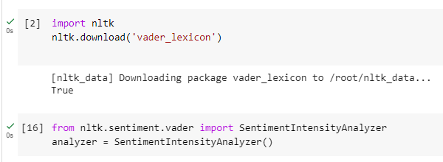

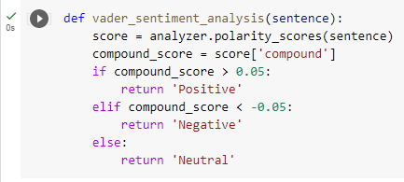

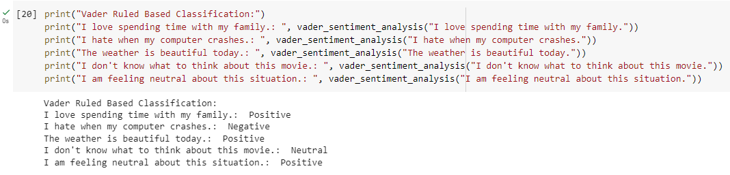

**Task # 2: Using python implements textBlob rules-based classification algorithm to find the sentiments of different sentences and compare the results with task # 01.**

**Solution:**

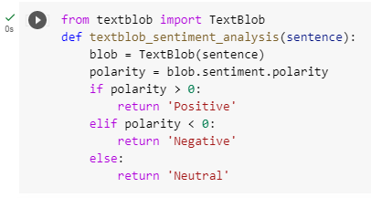

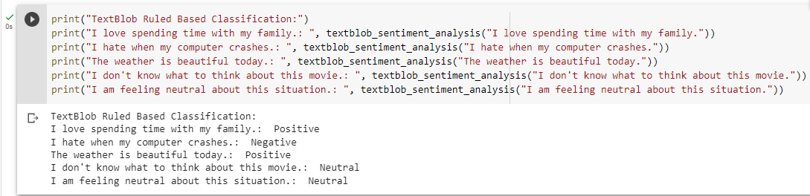

**Comparison:**

